Brooke School
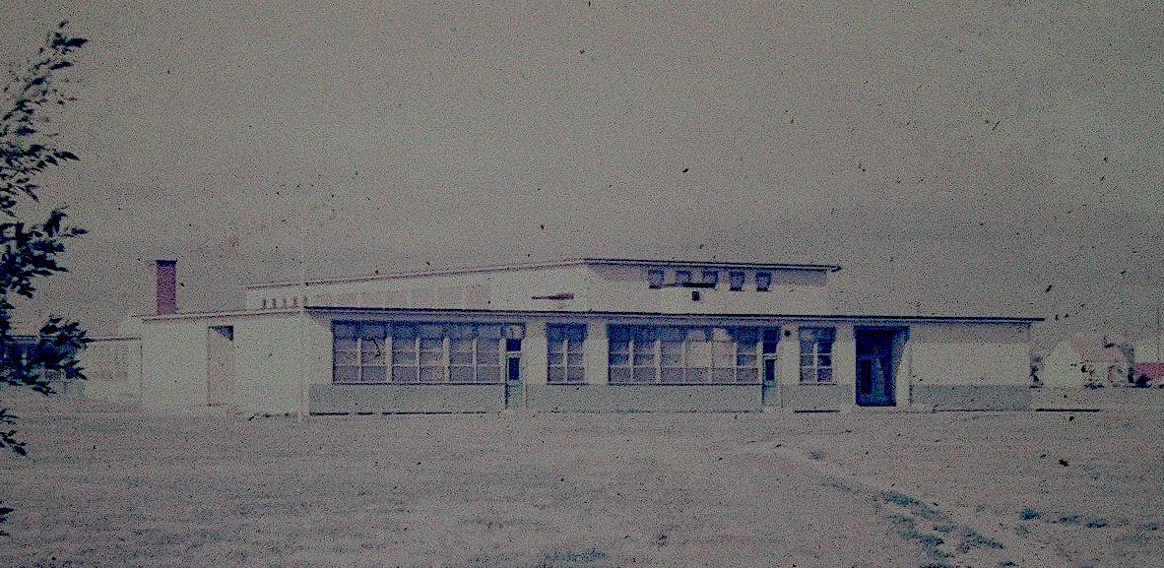

Brooke School - opened in 1948 in a building that later became the Teen Club

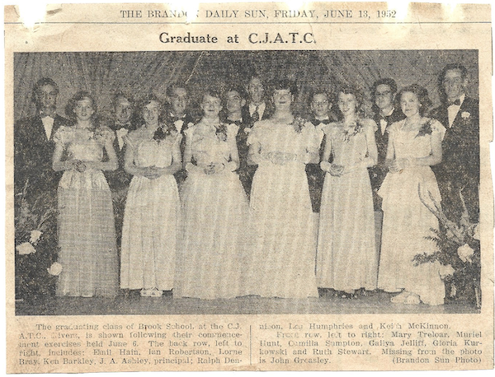
A school was built in 1951.
First Graduates - 1952

With the closing of the base, The school remained open for a time, serving the children of those in the Od-Za-We Kwun Program

Memories

Dora Irvine attended Brook School in the mid 60's. At that time classes for some grades were held in the GIS Building.

Judy McIntosh taught at Brooke in the last years before the Base closed and the first few years of the OO-ZA - We-Kwun Centre.

A Sad Memory

Our family was posted there in the early 1960's. I remember when they moved the lower grade school kids into
classrooms alongside the runway and we watched in horror one sunny day as a T-33 dove into the ground from an unknown cause. My dad (Ross Caldwell) was a radar tech and worked on all those planes and knew the pilot(s) so he was deeply affected.
Jim Caldwell

RCI and the Base
One of the more important connections between the Base and the Town was in the area of Education.

Retired teacher, D. H. Halstead provided this memory…

One of our challenges, as RCI teachers, was helping students get back on track as many had been transferred from province to province and of course from one school to another without having the opportunity of becoming accustomed to one set of standards or practices. Hopefully, we
succeeded!
I want to relate here an act of kindness that happened inside of one of my classrooms. One of the students who was a CJATC dependent had been shunted from school to school and by the time he came to RCI he was totally out of sync with the Math program. A separate program was found for him and I taught and tested him during the same periods as the other students. One day just after a test was given back student H said to student J "What did you get J. The reply came back “83” to which student H said "Way to go J".
As I write this I am also thinking of WWII and I know that a number of our students were children of WWII veterans. I know for certain that the father of two of my students was later diagnosed as having suffered PTSD and I wonder if there were others who suffered similarly. In addition, I and counselors , now know, that War can negatively affect the emotional region of the brain and consequently it is possible some of the homes would not have been as stable and loving as they otherwise might have been. Hence, the school might have, unknowingly, provided a safe emotional sanctuary for some students and for others a place to act out their survival needs. We will never know!

